Q-1. Write an SQL query to fetch “FIRST_NAME” from the Worker table using the alias name <WORKER_NAME>.

select FIRST_NAME as 'WORKER_NAME' from worker;

Q-2. Write an SQL query to fetch “FIRST_NAME” from the Worker table in upper case.

SELECT UPPER(FIRST_NAME) FROM WORKER;

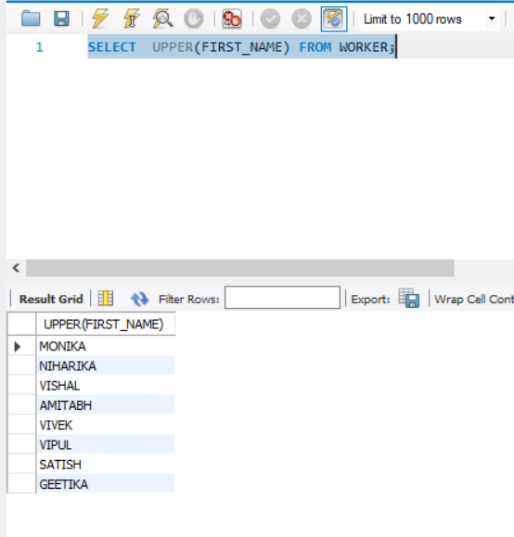

Q-3. Write an SQL query to fetch unique values of DEPARTMENT from the Worker table.

SELECT DISTINCT(DEPARTMENT) FROM WORKER;

Q-4. Write an SQL query to print the first three characters of FIRST_NAME from the Worker table.

SELECT SUBSTRING(FIRST_NAME,1,3) as FIRST_3_CHARACTERS FROM WORKER;

Q-5. Write an SQL query to find the position of the alphabet (‘a’) in the first name column ‘Amitabh’ from the Worker table.

SELECT INSTR(FIRST_NAME, BINARY 'a') AS Aposition FROM WORKER WHERE FIRST_NAME='Amitabh';

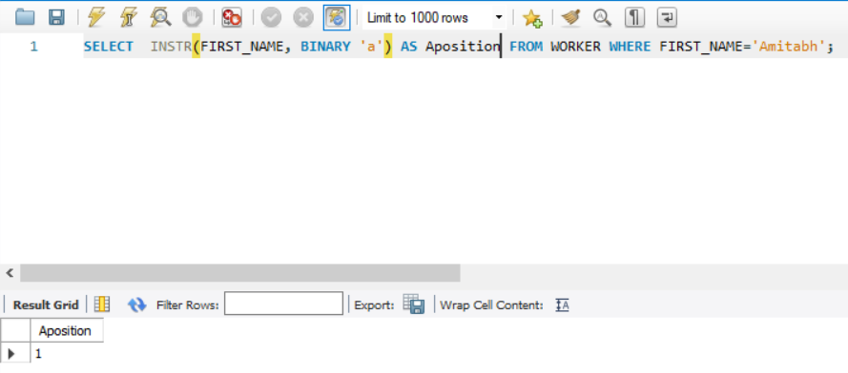

Q-6. Write an SQL query to print the FIRST_NAME from the Worker table after removing white spaces from the right side.

SELECT RTRIM(FIRST_NAME) FROM WORKER;

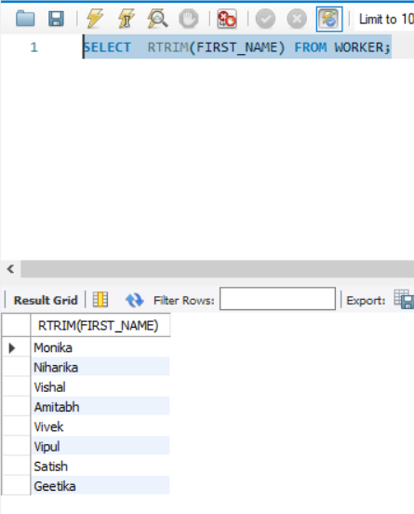

Q-7. Write an SQL query to print the DEPARTMENT from the Worker table after removing white spaces from the left side.

SELECT LTRIM(DEPARTMENT) FROM WORKER;

Q-8. Write an SQL query that fetches the unique values of DEPARTMENT from the Worker table and prints its length.

Q-9. Write an SQL query to print the FIRST_NAME from the Worker table after replacing ‘a’ with ‘A’.

SELECT REPLACE(FIRST_NAME, 'a','A') FROM WORKER;

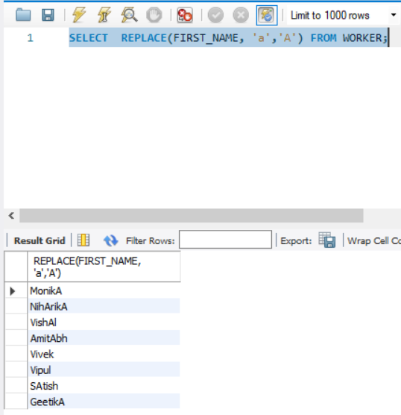

Q-10. Write an SQL query to print the FIRST_NAME and LAST_NAME from the Worker table into a single column COMPLETE_NAME. A space char should separate them.

SELECT CONCAT(FIRST_NAME, ' ', LAST_NAME) AS 'COMPLETE_NAME' FROM WORKER;

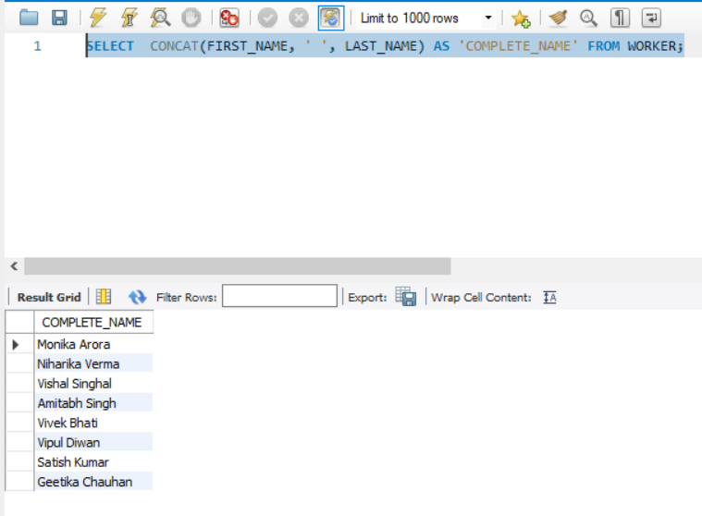

Q-11. Write an SQL query to print all Worker details from the Worker table order by FIRST_NAME Ascending.

SELECT * FROM WORKER ORDER BY FIRST_NAME ASC;

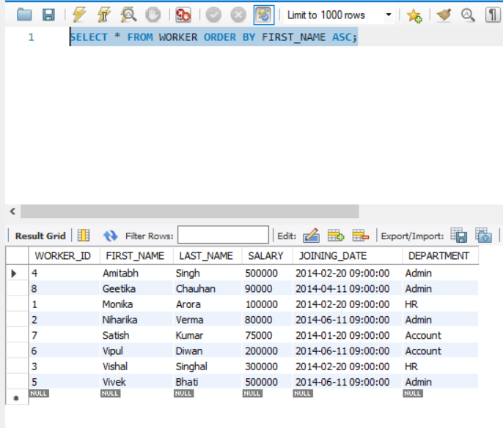

Q-12. Write an SQL query to print all Worker details from the Worker table order by FIRST_NAME Ascending and DEPARTMENT Descending.

SELECT * FROM WORKER ORDER BY FIRST_NAME ASC, DEPARTMENT DESC;

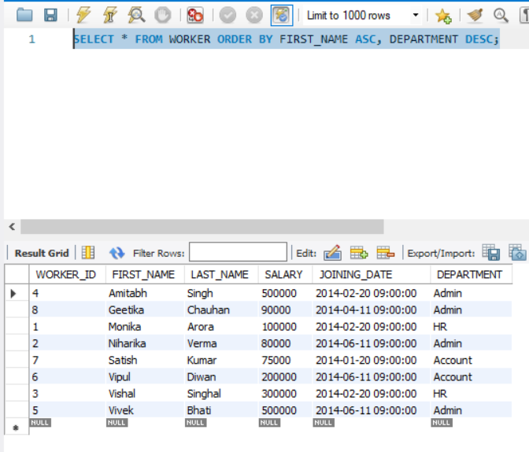

Q-13. Write an SQL query to print details for Workers with the first names “Vipul” and “Satish” from the Worker table.

SELECT * FROM WORKER WHERE FIRST_NAME IN ('Vipul','Satish');

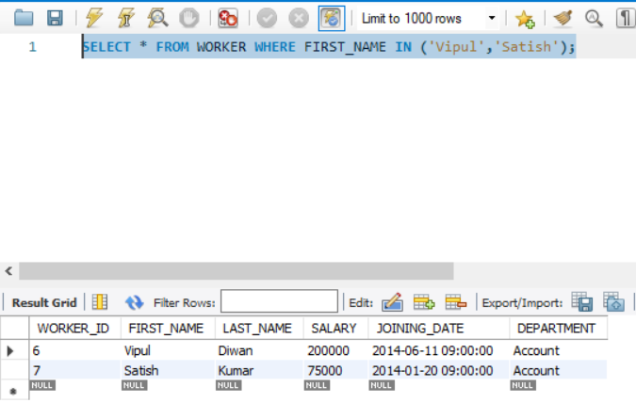

Q-14. Write an SQL query to print details of workers excluding first names, “Vipul” and “Satish” from the Worker table.

SELECT * FROM WORKER WHERE FIRST_NAME NOT IN ('Vipul','Satish');

Q-15. Write an SQL query to print details of Workers with DEPARTMENT name as “Admin”.

SELECT * FROM WORKER WHERE DEPARTMENT IN ('Admin');

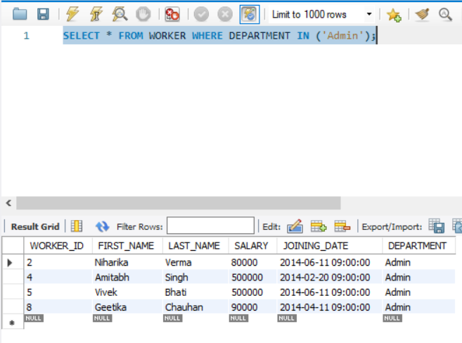

Q-16. Write an SQL query to print details of the Workers whose FIRST_NAME contains ‘a’.

SELECT * FROM WORKER WHERE FIRST_NAME LIKE '%a%';

Q-17. Write an SQL query to print details of the Workers whose FIRST_NAME ends with ‘a’.

SELECT * FROM WORKER WHERE FIRST_NAME LIKE '%a';

Q-18. Write an SQL query to print details of the Workers whose FIRST_NAME ends with ‘h’ and contains six alphabets.

SELECT * FROM WORKER WHERE FIRST_NAME LIKE '_____h';

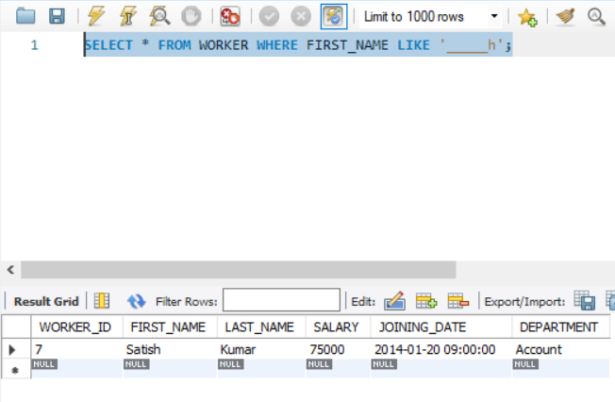

Q-19. Write an SQL query to print details of the Workers whose SALARY lies between 100000 and 500000.

SELECT * FROM WORKER WHERE SALARY BETWEEN 100000 AND 500000;

Q-20. Write an SQL query to print details of the Workers who joined in Feb’2014.

SELECT * FROM WORKER WHERE YEAR(JOINING_DATE)=2014 AND MONTH(JOINING_DATE)=2;

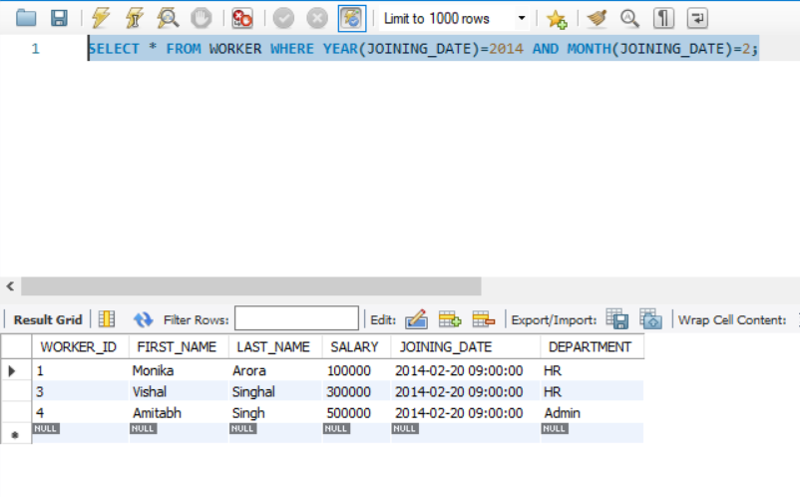

Q-21. Write an SQL query to fetch the count of employees working in the department ‘Admin’.

SELECT COUNT(*) AS ADMIN_COUNT FROM WORKER WHERE DEPARTMENT='Admin';

